  





**Eco-Friendly Habit Tracker**



|  |  |
| --- | --- |
|  |  |
|  |  |
|  |  |
|  |  |

**Deliverable number: 1**

**Date of submission: 29-03-2025**



**Eco-Friendly Habit Tracker**

**Introduction**

In today's fast-paced world, maintaining positive habits while balancing work, health, and personal growth can be challenging. The **Eco-Friendly Habit Tracker** is designed to help users effectively manage their daily routines by providing a structured and intuitive tracking system. To ensure smooth development and implementation, the project follows an organized **To-Do List**, where key tasks are systematically planned before execution. The initial phase of development focuses on essential features such as **user registration, login, habit creation, editing, deletion, and category assignment**. By addressing these fundamental tasks, the project establishes a strong foundation for a seamless and efficient habit-tracking experience, ultimately empowering users to stay consistent and motivated in their journey toward self-improvement.

**User Stories**

1. **User Sign-Up and Login** As a user, I want to sign up and log in so that my habit data is saved and synced across devices.
2. **Habit Management** As a user, I want to create, edit, and delete habits and assign them to predefined categories.

### User Stories and Specifications

#### 1. User Sign-Up and Login

* **User Story:** As a user, I want to sign up and log in so that my habit data is saved and synced across devices.
* **Sub-User Stories:**
  + As a user, I want to sign up using my email or social media accounts.
  + As a user, I want to log in securely using my credentials.
  + As a user, I want my habit data to be automatically synced across multiple devices.

#### 2. Habit Management

* **User Story:** As a user, I want to create, edit, and delete habits and assign them to predefined categories.
* **Sub-User Stories:**
  + As a user, I want to create a new habit with a name and category.
  + As a user, I want to edit an existing habit to update its details.
  + As a user, I want to delete a habit that I no longer need.
  + As a user, I want to assign habits to predefined categories such as Health, Work, and Productivity.

**Scrum Boards**

**Snapshot1**

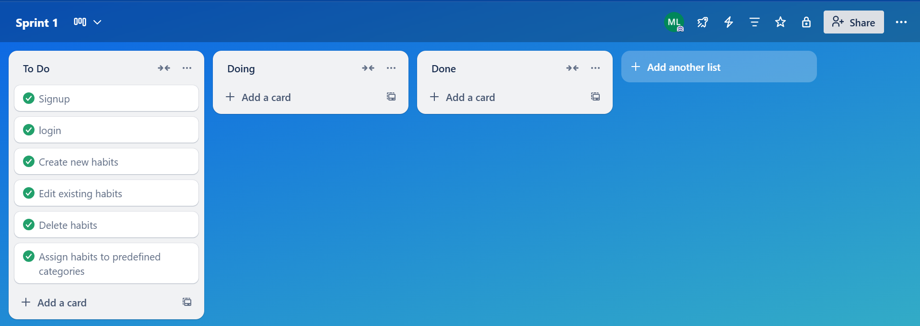

**Snapshot2**

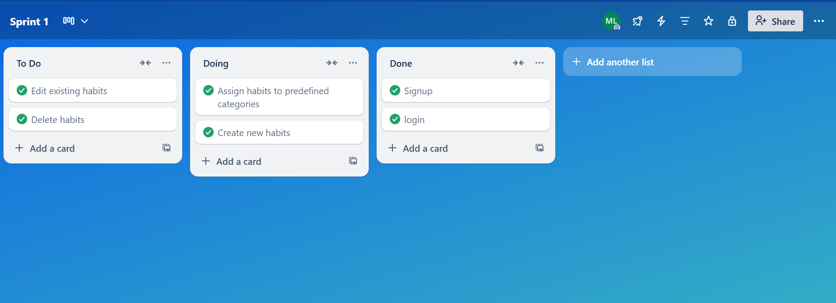

**Snapshot3**

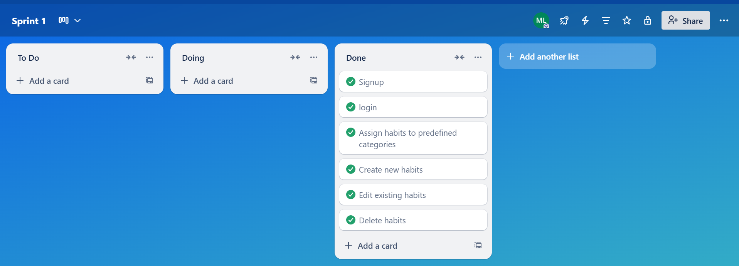

**Burn-Down-Chart**

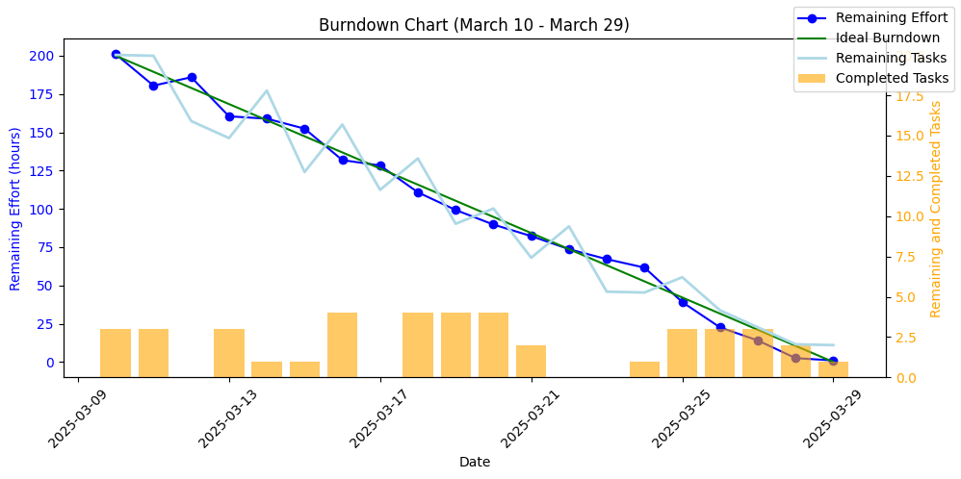

**NFR (Non-Functional Requirements) Specification**

**Performance:**

* The application should load the main page within 2 seconds.
* Database queries should be optimized to ensure that data retrieval and updates are performed within 1 second.

**Scalability:**

* The application should be able to handle up to 1000 concurrent users without performance degradation.
* The database should be designed to support future growth in the number of users and data volume.

**Security:**

* User passwords should be stored securely using hashing and salting techniques.
* The application should validate all user inputs to prevent SQL injections and other security vulnerabilities.

**Usability:**

* The user interface should be intuitive and easy to navigate.
* Error messages should be clear and provide guidance on how to resolve issues.

**Reliability:**

* The application should have an uptime of 99.9%.
* The application should handle unexpected errors gracefully and provide meaningful error messages to the user.

**Workload Division**

| Team directory | | |
| --- | --- | --- |
| **Team Member** | **Role** | **Responsibilities** |
| **Muhammad Daniyal Qureshi** | Lead & Backend Developer | Backend development, database integration, API implementation, and ensuring data security |
| **Muhammad Ahmad** | Frontend Developer & Architect | Designing UI/UX, implementing frontend logic, and integrating APIs with backend services |
| **Muhammad Sufyan** | Requirement Engineer & Tester | Gathering and refining requirements, writing test cases, performing software testing, and ensuring quality assurance. |

**Iteration 1 implementation screen shots**

**Signup:**

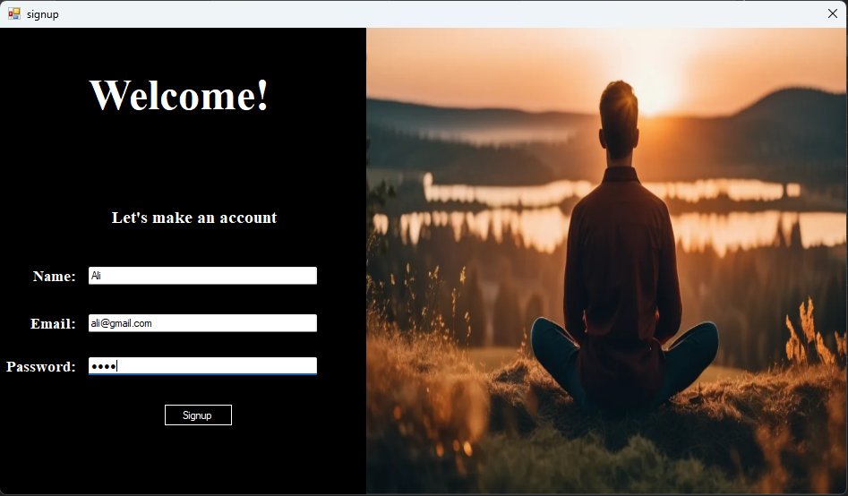

**Login:**

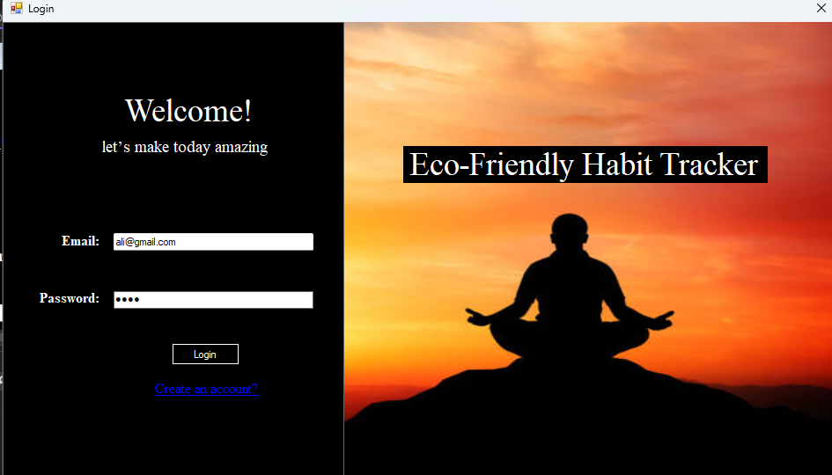

**MainPage:**

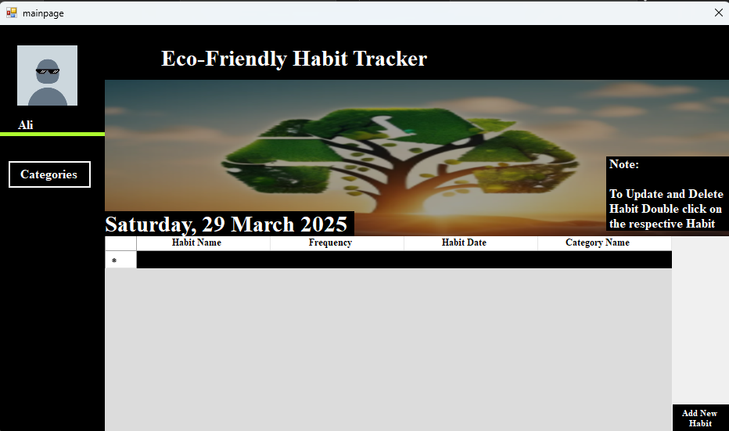

**Add Habit:**

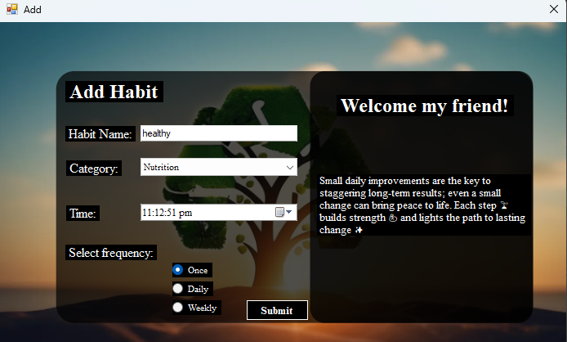

**Pic Upload:**

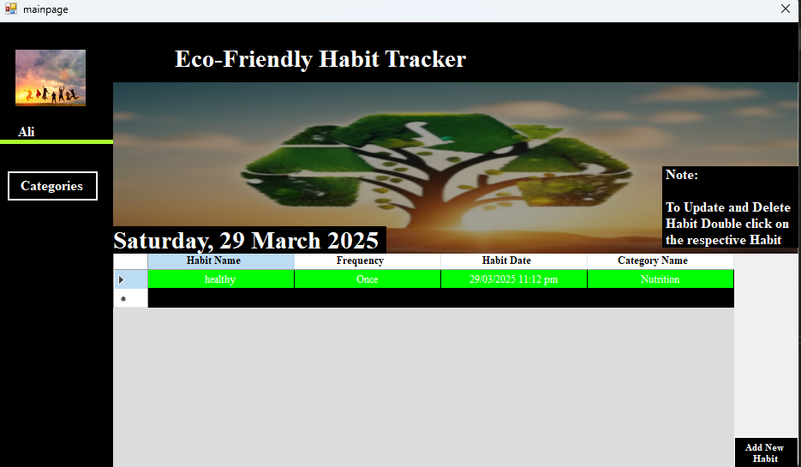

**Update Habit:**

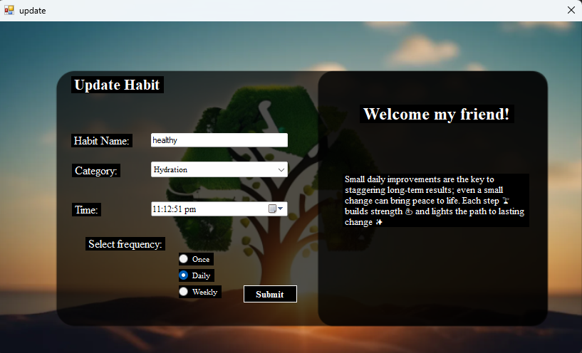

**Delete Habit:**

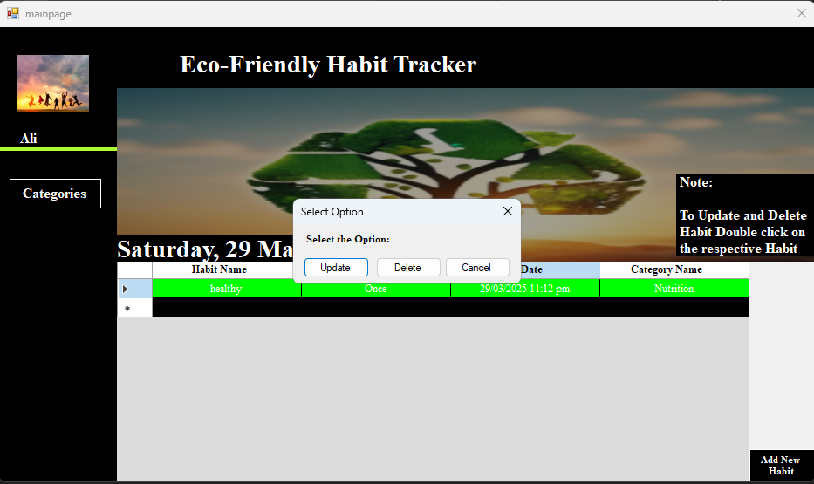

**Categories:**

